**Utilising Marble Dust and Fly Ash as Cement Replacement**

*A Project Report submitted by*

**Ankit Kumar**

*in partial fulfillment of the requirements for the award of the degree of*

Bachelor of Technology



**Indian Institute of Technology Jodhpur**

**Department of Civil and Infrastructure Engineering**

*November 2024*

**Abstract**

This study explores the use of marble dust and fly ash as partial replacements for cement in M25 concrete, addressing both environmental waste and concrete performance. Marble production in regions like Rajasthan generates large quantities of waste, while fly ash, a byproduct of coal combustion, accumulates in India. The paper investigates the effect of replacing 20% of cement with these waste materials, testing the concrete mixtures for compressive strength, workability, and ultrasonic pulse velocity (UPV). The results showed that both marble dust and fly ash can be effectively used without significant negative effects on the concrete's properties. The combined use of these materials offers an optimized solution, where marble dust improves density and void filling, and fly ash enhances long-term strength. This approach supports sustainable construction by reducing waste and the environmental impact of cement production.

**Contents**

|  |  |  |
| --- | --- | --- |
| **SN.** | **Section** | **Page** |
| 1 | Introduction | 1 |
| 2 | Material Properties | 2 |
| 3 | Mix Design | 5 |
| 4 | Material Required | 7 |
| 5 | Experiments | 7 |
| 6 | Observation Table | 10 |
| 7 | Discussion and Results | 11 |
| 8 | Conclusion | 15 |
| 9 | Reference | 16 |
| 10 | Appendix | 18 |

1. **Introduction**

Concrete is one of the most widely used construction materials in the world, owing to its durability, strength, and versatility. It consists of four primary components: cementing material (typically Portland cement), fine aggregates (such as sand), coarse aggregates (such as gravel or crushed stone), and water. The primary chemical reaction in cement production, known as the calcination process, occurs when limestone (calcium carbonate, $CaCO_{3}$) is heated to high temperatures in a kiln to produce calcium oxide ($CaO$), which is then mixed with other materials to form cement. This reaction releases significant amounts of CO₂ into the atmosphere. In addition to the direct emissions from the calcination process, energy consumption in cement production (typically from fossil fuels) also contributes to the overall carbon footprint of cement. It is estimated that the cement industry accounts for approximately 7% of global $CO_{2}$ emissions. [1][2]

The production of cement is a significant contributor to environmental pollution, as the cement manufacturing process is energy-intensive and releases substantial amounts of $CO_{2}$ into the atmosphere, contributing to global warming and climate change [3]. As the global demand for cement continues to rise due to rapid urbanization and infrastructure development, the environmental challenges associated with cement production become more critical.

In regions like Rajasthan, especially in areas such as Makrana, the marble industry is a significant economic contributor, but it also generates vast amounts of waste. The primary by-product of marble production is fine marble dust, which, when not managed properly, creates considerable environmental challenges. The marble industry in India produces an estimated 12 million tonnes of waste annually, with a large portion being fine dust that is difficult to manage [4]. Marble dust can have detrimental effects on soil quality, increasing soil alkalinity and reducing fertility [5]. Moreover, fine marble dust suspended in the air poses serious health risks, including respiratory issues when inhaled [6].

In a similar vein, fly ash—a by-product of coal combustion in thermal power plants—is another major environmental concern across India. India produces around 150 million tonnes of fly ash annually, with only a portion being utilized in construction [2]. Vast quantities of fly ash accumulate every year, posing disposal challenges and leading to environmental pollution. Both fly ash and marble dust present opportunities for reuse in various applications, particularly in the construction sector. The use of these waste materials as partial replacements for cement in concrete production has the potential to reduce environmental pollution, minimize waste disposal issues, and lower the demand for natural resources [7].

This paper aims to investigate the effect of using marble dust and fly ash as partial replacements for cement in M25 concrete mixtures. A 20% cement replacement ratio was adopted, and the resulting concrete mixtures were tested for compressive strength, workability, and ultrasonic pulse velocity (UPV). By reusing waste materials like marble dust and fly ash, the study explores an environmentally sustainable solution to construction material production while addressing the growing concern of waste management in India.

1. **Material Properties**
2. Cement:

* Type: OPC 43
* Specific gravity: 3.2
* Fineness: 14% or 3,138.3 $\frac{cm^{2 }}{g}$
* Consistency: 31%
* Initial Setting Time: 130 min

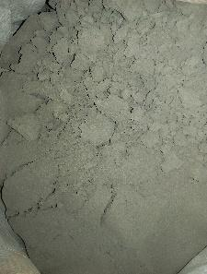

Figure 1: OPC 43

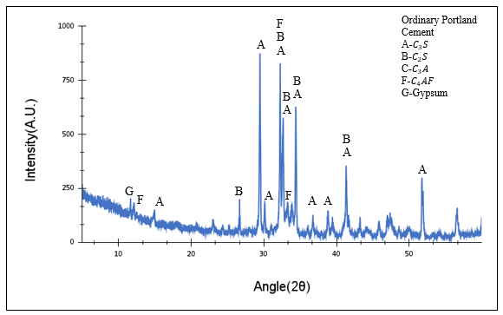

Figure 2: XRD-Analysis for Cement

From the XRD analysis of our cement, it is evident that all the major phases are present. These include the clinker minerals such as alite (C₃S), belite (C₂S), tricalcium aluminate (C₃A), and calcium ferrite (C₄AF). Additionally, minor phases like gypsum and calcium carbonate (calcite) were also observed, confirming the presence of all key phases typically found in cement. This comprehensive phase composition plays a crucial role in the cement's hydration and strength development. [8]

1. Fine Aggregate:

* Specific gravity: 2.46

Figure 3: Fine Aggregate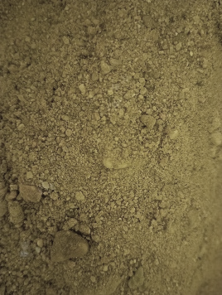s: procured from the Luni River in Rajasthan

1. Coarse Aggregate:

* Specific gravity: 2.73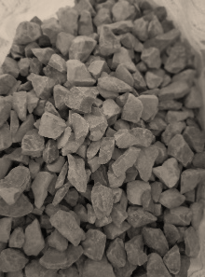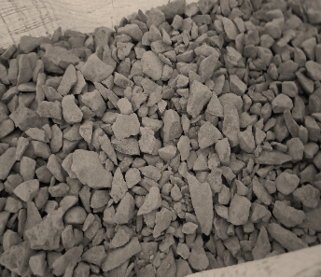

Figure 4: Coarse Aggregates

1. Marble Dust:

* The marble powder was dried in an oven at a temperature of 100 ± 5 °C 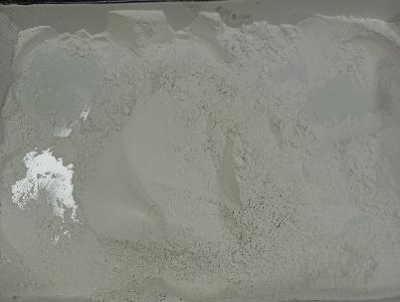

Figure 5: Marble Dust : procured from makrana

Figure 6: XRD-Analysis for Marble Dust

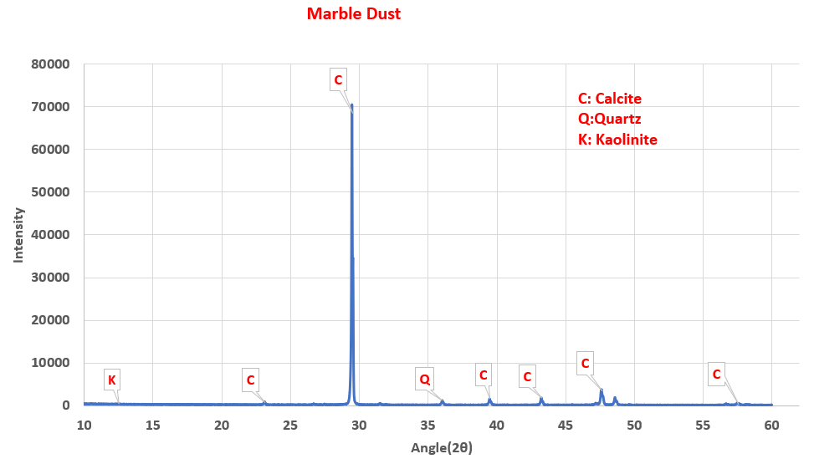

Examining general XRD patterns for marble dust from Figure 6 reveals that, besides its primary composition of calcite, marble dust also contains trace amounts of quartz and kaolinite. In our sample, calcite is the predominant phase. While this could potentially lead to minor carboaluminate formation upon reaction with C₃A, the marble dust remains largely inert. Although it could serve as a filler, in our case, it is not finely ground or uniformly mixed, which limits its effectiveness. [9]

1. Fly Ash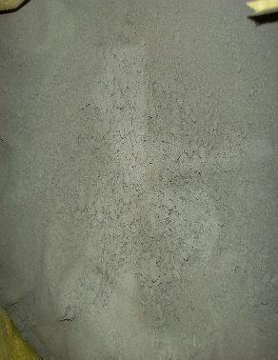

Figure 7: Fly Ash

The Fly ash we obtained contains amorphous silica, which has pozzolanic properties and reacts with calcium hydroxide in cement to enhance binding. Additionally, the presence of mullite in fly ash improves strength, thermal stability, and chemical resistance in the final product. [10]

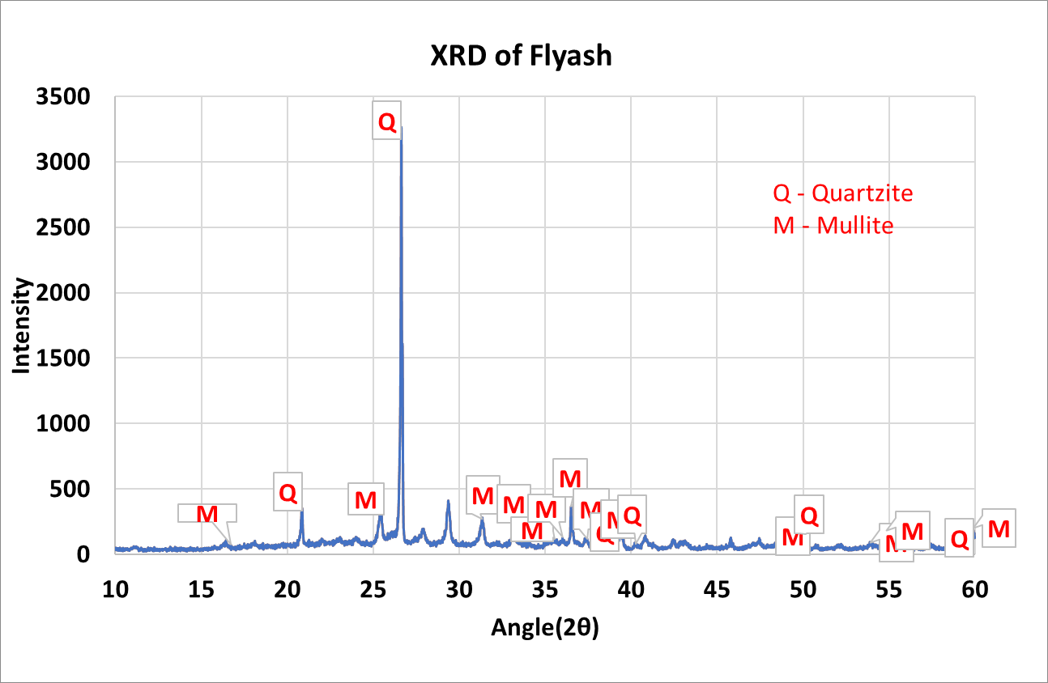

Figure 8: XRD-Analysis for Fly Ash

1. **Mix Design (For M25) [11] [12]**

3.1 Target Strength:

$$f_{m}=Max \{f_{ck}+1.64σ, f_{ck}+X \}$$

Here,

$X=$ Factor Based on grade of concrete (From Table A-1) = 5.5

$σ=$ Standard Deviation (From Table A-2) = 4

$f_{ck}=$ Characteristic Strength of Concrete = 25 N/mm2

Mean Compressive Strength

* 1. Water Cement Ratio:

1. Exposure (From table A-3): Moderate
2. Minimum Cement Content $\left(\frac{kg}{m^{3}}\right)$ (From table A-4): 300
3. Maximum Free water cement Ratio (From table A-4): 0.5
4. Type of Cement and grade of cement: OPC 43
5. Water Cement Ratio (From Fig. A-1): 0.45
   1. Water Content:
6. Maximum Nominal Size of Aggregate: 20 mm
7. Water Content (From table A-5) $\left(\frac{kg}{m^{3}}\right)$: 186
8. Workability in terms of Slump Value (Ideal 50 mm): 50 mm (Clause A-1)
9. Type of admixture (either "Water Reducing" or "Super Plasticizer" or Nil): Nil
10. Water Content $\left(\frac{kg}{m^{3}}\right)$: 186 (Clause A-2)
    1. Cement Content:

* Cement Content: Water Cement Ratio $×$ Water Content = 413.33 $\left(\frac{kg}{m^{3}}\right)$ (Clause A-3)
  1. Aggregates:
  2. Fine Aggregate Zone (From Table A-7): 2
  3. Volume of CA (per unit volume of total aggregates, From Table A-6): 0.62

(Clause A-4)

* 1. Volume of CA (per unit volume of total aggregates): 0.63
  2. Volume of CA (per unit volume of total aggregates): 0.63 (Clause A-5)
  3. Volume of FA (per unit volume of total aggregates): 1 - 0.63 = 0.37
  4. Mix Calculations:
* Volume of Concrete $(m^{3})$: 1
* Volume of Cement $(m^{3})$: $\frac{Cement Content}{{SG}_{Cement}×ρ_{water}}=$ 0.13
* Volume of Water $(m^{3})$: $\frac{Water Content}{{SG}_{water}×ρ_{water}}=$ 0.186
* Admixture (Present or Absent): Absent
* Mass percentage of admixture (like 1.1% of mass of cement): 1.1
* Specific Gravity of Admixture: 1.12
* Volume of admixture $(m^{3})$: $\frac{Mass Percentage × Cement Content}{{SG}_{admixture}×ρ_{water}}$ = 0 (Note : No admixture is used)
* Volume of Aggregates: 1 - Volume of admixture - Volume of Cement - Volume of water = 0.68
* Volume of Coarse Aggregates $(m^{3})$: Volume of CA x Volume of Aggregates = 0.43
* Volume of Fine Aggregates $(m^{3})$: Volume of FA x Volume of Aggregates = 0.25
* Mass of Coarse Aggregate(kg): ${SG}_{CA} x ρ_{water} x Volume of CA=$ 1177.84
* Mass of Fine Aggregate(kg): ${SG}_{FA} x ρ_{water} x Volume of FA=$ 623.34

**4. Materials Required**

Table 1:

Mix proportions for different concrete compositions incorporating marble dust and fly ash as partial cement replacements.

|  |  |  |  |  |  |  |  |
| --- | --- | --- | --- | --- | --- | --- | --- |
|  | **Number of Cubes Casted** | **OPC 43**  **(Kg)** | **Coarse Aggregate (Kg)** | **Fine Aggregate (Kg)** | **Water**  **(Kg)** | **Marble Dust**  **(kg)** | **Fly Ash**  **(Kg)** |
| **M25** | 12 | 20.088 | 57.24 | 30.29 | 9.04 | 0 | 0 |
| **M25+20% Marble Dust** | 12 | 16.068 | 57.24 | 30.29 | 9.04 | 4.02 | 0 |
| **M25+20%Fly Ash** | 12 | 16.068 | 57.24 | 30.29 | 9.04 | 0 | 4.02 |

**5. Experiments**

1. 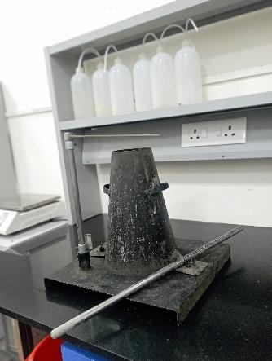Slump Cone Test [13]:

Figure 9: Slump Cone Apparatus

Concrete is considered workable if it can be mixed, placed, compacted, and finished without issues like segregation or bleeding. Segregation occurs when coarse aggregates separate from finer materials, leading to voids and reduced durability. Bleeding happens when excess water rises to the surface, creating pores throughout the concrete, which weakens it. The vertical settlement of fresh concrete, known as slump, measures its consistency and workability. The slump test, conducted using a slump cone as in Figure 9, involves filling fresh concrete into a frustum-shaped cone (200 mm bottom diameter, 100 mm top diameter, 300 mm height) and measuring the settlement after removing the mold.

1. Ultrasonic Pulse Velocity Test [14]:

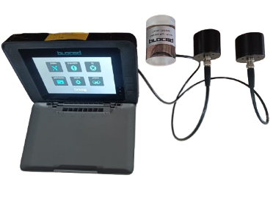The ultrasonic pulse velocity (UPV) test assesses concrete quality by measuring pulse travel speed through the material. Generated by a transducer, the pulse creates stress waves (longitudinal, shear, and surface) within the concrete. The fastest, longitudinal wave, is detected first by the receiver. Pulse velocity is primarily influenced by the concrete’s density, homogeneity, and elasticity, making it ideal for evaluating structural integrity. Higher velocities indicate good-quality concrete, while lower velocities suggest defects like cracks or voids, as the pulse path becomes longer around such discontinuities. Aggregate density and elasticity also significantly impact pulse velocity.

Figure 10: Ultrasonic Pulse Velocity Meter

5.3 Rebound Hammer Test [15]:

The Rebound Hammer Test, also known as the Schmidt Hammer Test, is a non-destructive test that estimates the surface hardness and compressive strength of concrete. In this test, a spring-loaded hammer is released to strike the concrete surface with a specific amount of energy. The rebound distance of the hammer is measured, which reflects the surface hardness and correlates with the compressive strength of the concrete.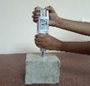

Figure 11: Rebound Hammer Apparatus

1. Compressive Strength Test [16]:

The compressive strength of cement concrete is a critical property, influencing other material properties. According to IS: 516 (1959), concrete is tested using a standard cube mould of 150 mm x 150 mm x 150 mm, where concrete is poured, compacted, and smoothed. After 24 hours, the mould is removed, and the specimen is placed in a curing tank for further maturation. Compressive strength tests are conducted at 7 and 28 days using a Compression Testing Machine (CTM), applying load gradually at a rate of 140 $\frac{kg}{cm^{2}}$ per minute until failure. The peak load is divided by the cross-sectional area to calculate the compressive strength.

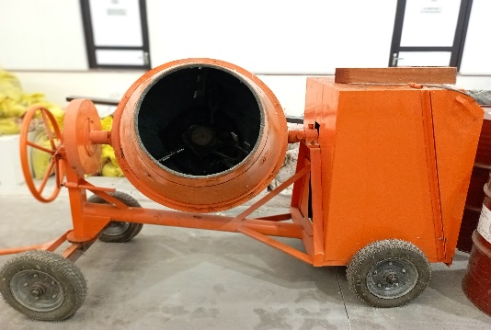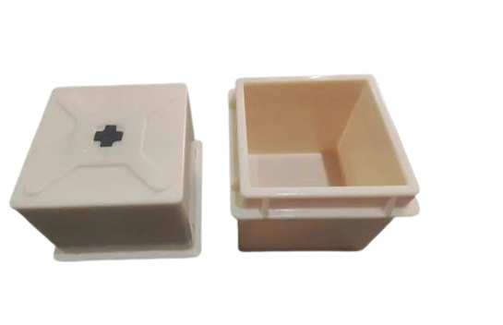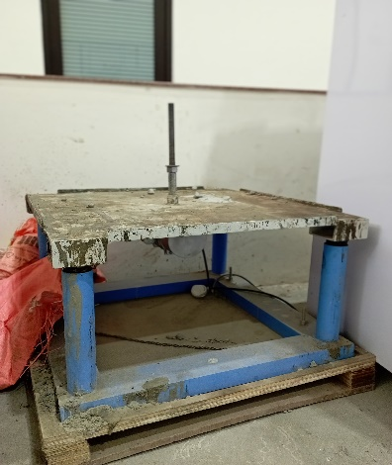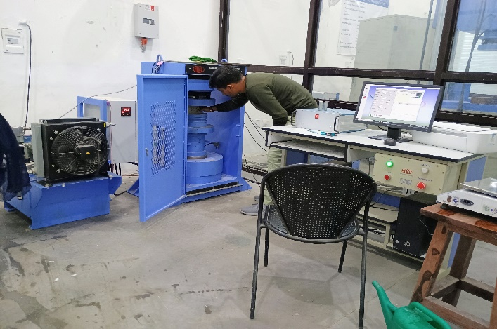

(a)

(b)

(c)

(d)

Figure 12: (a) Concrete Mixer (b) 150 mm Cube Mould (c) Concrete Vibration Table

(d) Compressive Testing Machine

**6. Observations:**

Table 2: Concrete Property Test Results:

slump tests, 7-day compressive strength tests, and ultrasonic pulse velocity (UPV) tests conducted on different concrete mixes.

|  |  |  |  |  |  |  |  |  |  |  |
| --- | --- | --- | --- | --- | --- | --- | --- | --- | --- | --- |
|  | Slump Value (mm) | 7-Day CTM Test | | | | | | | UPV | |
|  |  | Cube 1 | Cube 2 | Cube 3 | Cube 4 | Cube 5 | Cube 6 | Average  (MPa) | Ultra  -Pulse Velocity  (km/s) | Quality of Concrete |
| M25 | 70 | 24.48 | 24.97 | 22.14 | 25.78 | 25.5 | 23.9 | 24.48 | 0.91 | Doubtful |
| M25 + 20%  Marble Dust | 65 | 21.3 | 21.16 | 19.16 | 21.35 | 22.3 | 20.2 | 20.54 |  | |
| M25 + 20%  Fly Ash | 70 | 24.02 | 24.61 | 23.46 | 24 | 25.0 | 25.3 | 24.42 |

Table 3: Concrete Property Test Results:

28-day compressive strength tests, ultrasonic pulse velocity (UPV) and rebound hammer tests conducted on different concrete mixes.

|  |  |  |  |  |  |  |  |  |  |  |  |
| --- | --- | --- | --- | --- | --- | --- | --- | --- | --- | --- | --- |
|  | **CTM Test** | | | | | | | **UPV Test** | | **Rebound Hammer Test** | |
|  | Cube 1 | Cube 2 | Cube 3 | Cube 4 | Cube 5 | Cube 6 | Average  (MPa) | Ultra-Pulse Velocity  (km/s) | Quality of Concrete | Rebound Number | Quality of Concrete |
| M25 | 31.84 | 29.1 | 28.27 | 27.5 | 29.95 | 30.92 | 29.6 | 4.75 | Excellent | 17 | Poor concrete |
| M25 + 20%Marble Dust | 27.4 | 25.94 | 19.77 | 27.87 | 25.52 | 26.38 | 25.48 | 4.2 | Good |  | |
| M25 + 20%Fly Ash | 30.92 | 30.25 | 31.26 | 31.32 | 25.92 | 28.25 | 29.65 | 5.37 | Excellent |

* At 7 days, concrete microstructure is still young and its properties are still developing. UPV results might not accurately correlate to the 28-day strength.
* The Rebound Hammer test is not recommended for concrete less than 14 days old due to the risk of surface damage. [5]
* Rebound hammer test's accuracy can also be influenced by factors like surface moisture and smoothness. Excess moisture, in particular, can lower rebound readings and result in inaccurate strength estimations. To address this, it’s recommended to allow the surface to dry for 24 hours before testing to normalize moisture content. Additionally, the compressive strength test should be conducted within 2 hours of removing the sample from the curing tank. Since the Rebound Hammer test is a non-destructive test (NDT) and the compressive strength test is a destructive test, it can be challenging to perform both on the same cube without conflicting time requirements. [15]

Point of Impact

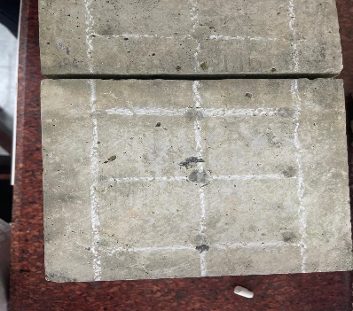

Figure 13: Rebound Hammer Test Impact on Surface at 28-Day Test

* Performing the Rebound Hammer test immediately after removing a cube from the curing tank may damage its surface, making it unsuitable for testing with the Compressive Testing Machine (CTM). As a result, we don't conduct the Rebound Hammer test on other concrete mixes.

**7. Discussion and Results:**

7.1 Slump Cone Test 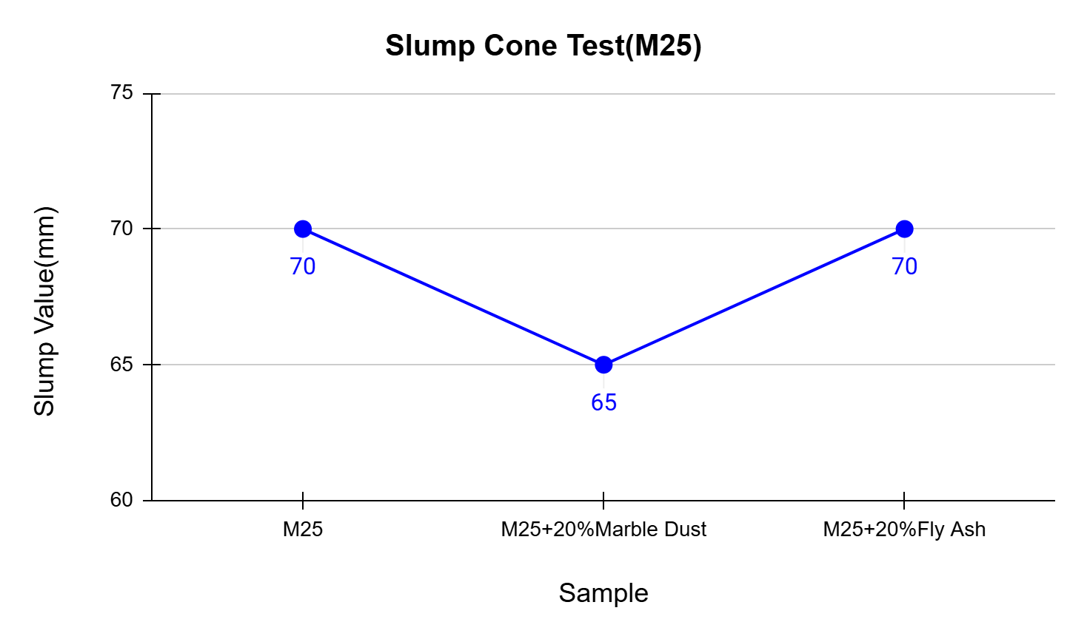

Figure 14: Slump Values Indicating the Workability of Various Concrete Mixes

Figure 14 illustrates that at 20% partial replacement, slump value of concrete mix does not significantly affect slump value of concrete mix. The slump value is slightly reduced when marble dust is added, dropping from 70 mm to 65 mm. This decrease in slump can be attributed to the fineness and high surface area of marble dust, which requires more water to wet the surface and enhance cohesion within the concrete mix. This increased cohesion can fill voids between sand particles, which limits the workability of the concrete. To counteract this, superplasticizers are commonly used to improve workability when marble powder is added. [17]

In contrast, adding 20% fly ash does not significantly change the slump value compared to the standard M25 mix. Fly ash particles, due to their spherical shape, help maintain workability by reducing water demand, which allows for a lower dosage of admixture compared to mixes with marble powder. [17]

7.2 Curing

When curing concrete cubes in a tank, certain factors need to be considered:

1. Spacing: Adequate spacing between the cubes is crucial to ensure proper water circulation and uniform curing. Without sufficient space, some surfaces might not cure properly, leading to inconsistent strength development.
2. Submergence: The cubes should be fully submerged in the water to maintain consistent moisture on all surfaces.
3. Water Quality: Algae can grow on concrete cubes during curing because the wet surface and sunlight make a good home for them. This can make the surface a bit slippery and might make it harder to get accurate results from some tests (Rebound Hammer Test, UPV Test). It's like a thin green film growing on the cube.

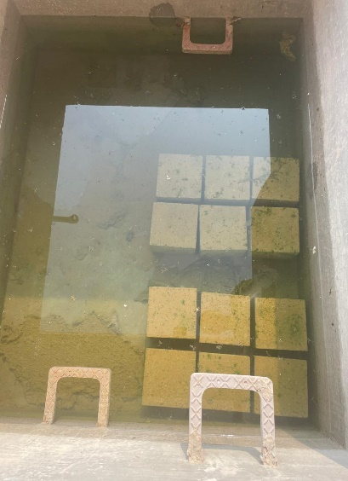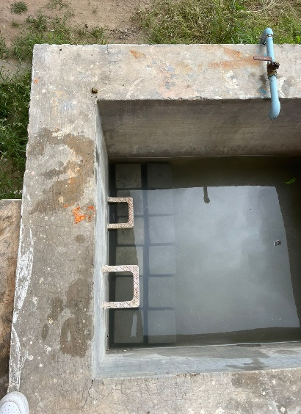

(a)

(b)

Figure 15: (a) Early Days of Curing with Clean Water (b) Algae Growth After Several Days

7.3 Compressive Strength Test

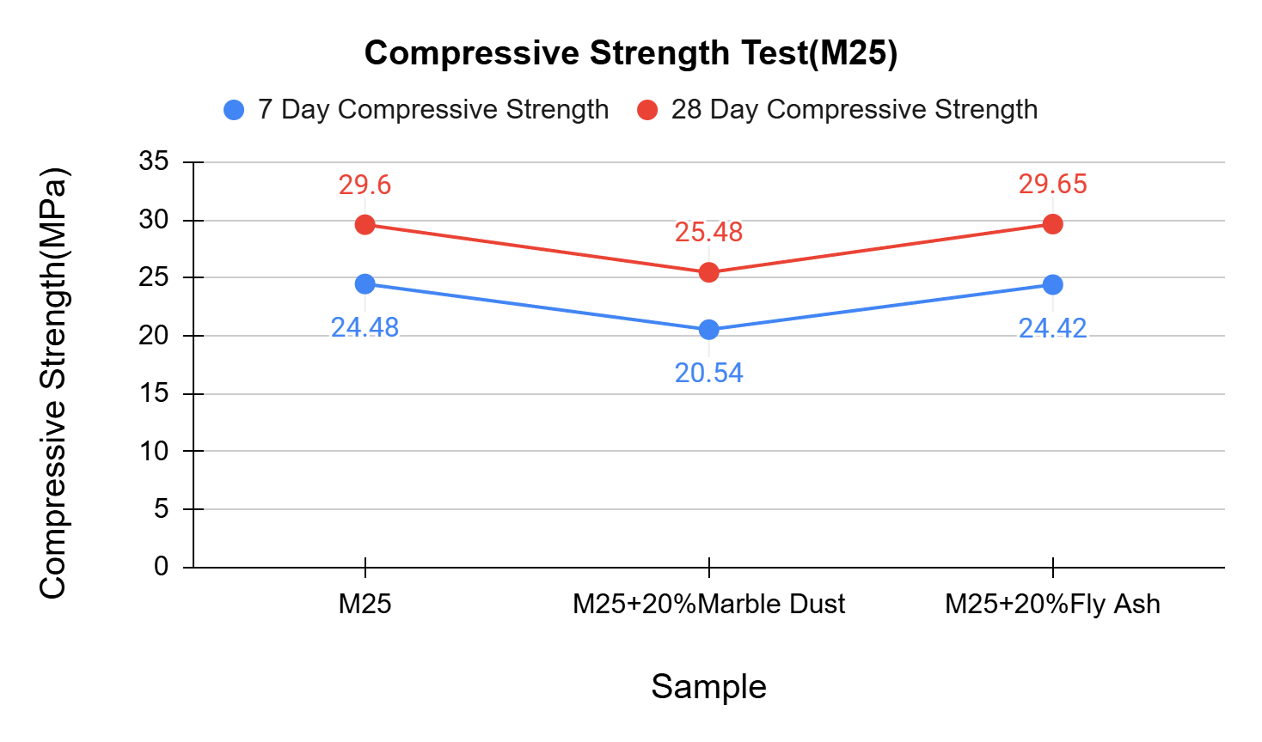

Figure 16: Compressive Strength Test

* When 20% marble dust is added, there is a noticeable drop in both 7-day (16.06%) and 28-day (13.92%) compressive strength. This reduction in strength can be attributed to the fact that marble dust is largely inert and does not actively participate in the hydration process. Unlike cement, it does not contribute to the formation of additional C-S-H compounds. Marble dust essentially acts as a filler material, which can improve the density of the concrete matrix but does not enhance the chemical bonding strength. This is why no significant strength increase is observed, and strength values remain lower than the reference mix. [18] [17]
* Fly ash, unlike marble dust, is a pozzolanic material, meaning it can react with calcium hydroxide (a by-product of cement hydration) to form additional C-S-H gel. This reaction contributes to long-term strength development, although it may not be as pronounced at early stages (like at 7 days). The spherical particles of fly ash also enhance the workability of the concrete, which helps achieve good compaction, indirectly supporting strength gains. At 28 days, the concrete with fly ash achieves a strength very close to the control mix (29.65 MPa vs. 29.6 MPa for control). This shows that the pozzolanic reaction of fly ash compensates for the initial dilution effect over time.

Figure 17:(a) Cracking Pattern: All samples exhibit satisfactory failure modes. (b) Failure Patterns [21]

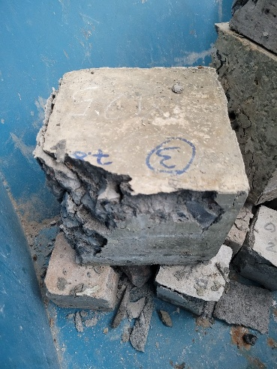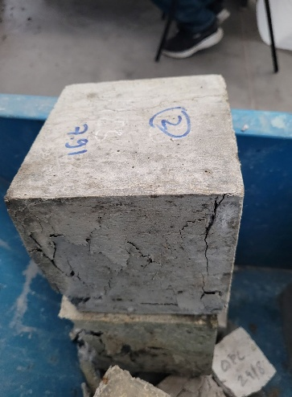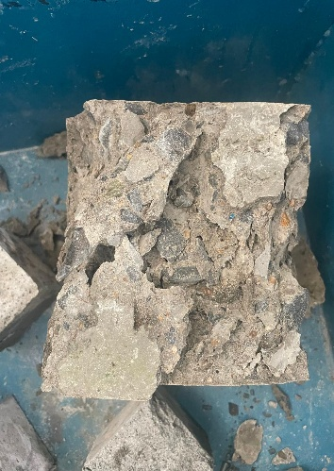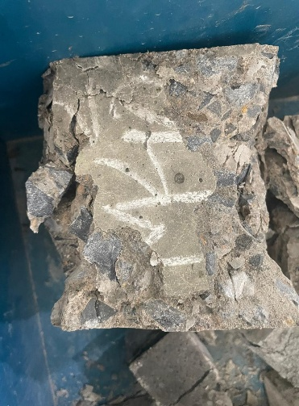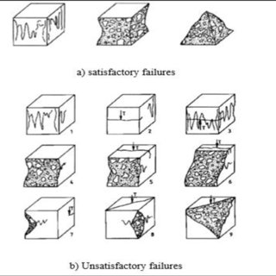

(a) (b)

7.4 UPV Test:

* Sound waves travel faster through denser materials. Concrete with higher compressive strength typically has a denser microstructure due to better compaction and hydration of cement.This denser structure allows sound waves to propagate faster, resulting in a higher UPV. [19]
* The lower ultrasonic pulse velocity (UPV) value at 20% marble dust replacement can be attributed to its behavior as an inert filler material. While marble dust has finer properties compared to cement, it primarily acts as a micro-filler rather than contributing significantly to hydration and chemical bonding. As a result, at higher replacement levels (such as 20%), it may not sufficiently enhance the microstructure's density and strength. Instead, excessive replacement can disrupt the optimal cement matrix, leading to increased porosity and reduced homogeneity in the concrete, which negatively affects UPV readings.

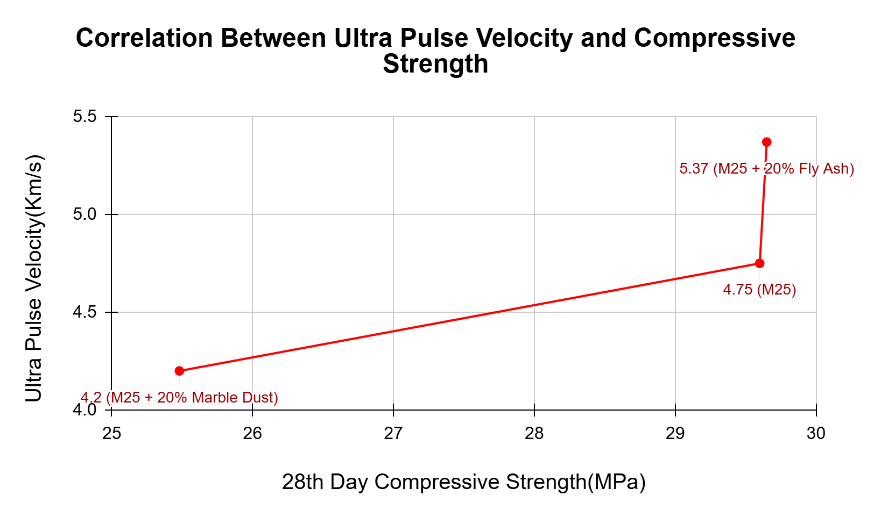

Figure 18: Relationship between the ultrasonic pulse velocity and compressive strength of

concrete

* Research supports this observation, showing that marble dust enhances concrete's properties up to an optimal replacement level (typically around 10-15%) but can degrade performance beyond this point. Excessive replacement decreases compressive strength and increases water absorption, indicating reduced compaction and connectivity of the microstructure​. [20]

**8. Conclusions**

The present study demonstrates the potential for utilizing marble dust and fly ash as partial replacements for cement in M25 concrete. The addition of these waste materials not only helps address environmental issues associated with their disposal but also offers benefits to concrete properties. The results show that, at a 20% replacement level, both marble dust and fly ash can be effectively used without significant adverse impacts on the concrete's workability and strength properties.

Our research suggests there are possibilities that partially replacing cement with both marble dust and fly ash can significantly enhance concrete properties across the board. This combination offers environmental benefits by reducing reliance on cement production, and economic advantages due to the lower cost of these supplementary materials. Furthermore, the blend improves the concrete's physical characteristics: the marble dust and fly ash increases density, while the spherical fly ash particles enhance workability, counteracting the reduced workability typically associated with the fine marble dust particles. This approach aligns with sustainable practices, reducing waste disposal issues and minimizing the environmental impact of cement production, while still achieving the desired performance in concrete applications.

**9. References**

1. Allwood, J. M., & Cullen, J. M. (2012). Sustainable materials: With both eyes open. UIT Cambridge.
2. Dhar, A., & Verma, A. (2018). Utilization of fly ash in concrete: A review. International Journal of Environmental Engineering.
3. IPCC. (2007). Climate Change 2007: Mitigation of Climate Change. Contribution of Working Group III to the Fourth Assessment Report of the Intergovernmental Panel on Climate Change. Cambridge University Press.
4. Pillai, R. S., & Swaminathan, M. (2016). Marble dust as a partial replacement of cement in concrete. International Journal of Research in Engineering and Technology
5. Mekki, A., Mekki, A., & Aloui, F. (2018). Environmental impact of marble dust on soil quality and its potential uses. Environmental Science and Pollution Research
6. Koul, P., Gupta, D., & Sharma, S. (2015). Marble dust: A waste material in concrete production. International Journal of Advanced Technology in Engineering and Science
7. Rathod, A., & Thakur, M. (2020). Use of marble dust and fly ash in concrete: A sustainable approach. *Materials Science Forum*
8. Walenta, G., & Füllmann, T. (2004, March). Quantification of Portland cement and blended cement using Rietveld X-ray diffraction analysis. Powder Diffraction, 19
9. Ali, A. H., Abd El-Aleem, S., & Heikal, M. (2013, November). Effect of limestone filler on the hydration characteristics of Portland cement pastes. Chemistry and Materials Research, Special Issue, International Congress on Materials & Structural Stability.
10. Golewski GL. The Role of Pozzolanic Activity of Siliceous Fly Ash in the Formation of the Structure of Sustainable Cementitious Composites. Sustainable Chemistry. 2022; 3(4):520-534. https://doi.org/10.3390/suschem3040032
11. IS 456-2000, Plain and Reinforced concrete- Code of Practice, Bureau of Indian Standard (BIS), New Delhi, India
12. IS 10262:2019, Plain and Reinforced concrete- Code of Practice, Bureau of Indian Standard (BIS), New Delhi, India
13. IS 1199 Part 2 - 2018, Fresh Concrete - Methods of Sampling, Testing and Analysis Bureau of Indian Standard (BIS), New Delhi, India
14. IS 13311 Part 1 - 1992, Methods of physical tests for hydraulic cement Bureau of Indian Standard (BIS), New Delhi, India
15. IS 13311 Part 2 - 1992, Methods of physical tests for hydraulic cement Bureau of Indian Standard (BIS), New Delhi, India
16. IS 516 Part 1 - 2021, Harden Concrete Method of Test Bureau of Indian Standard (BIS), New Delhi, India
17. Aliabdo, A.A., Abd Elmoaty, A.E.M., & Auda, E.M. (2014). Re-use of waste marble dust in the production of cement and concrete. Construction and Building Materials, 50, 28–41.
18. Miss Meera, Supratic Gupta, Performance evaluation of marble powder and fly ash concrete for non-structural applications, Journal of Building Engineering, Volume 84, 2024, 108499, ISSN 2352-7102, https://doi.org/10.1016/j.jobe.2024.108499.
19. Belouadah, M., Rahmouni, Z.E., Tebbal, N., El Hassen Hicham, M. (2021). Evaluation of concretes made with marble waste using destructive and non-destructive testing. Annales de Chimie - Science des Matériaux, Vol. 45, No. 5, pp. 361-368. https://doi.org/10.18280/acsm.450501
20. Yang D, Zhao J, Suhail SA, Ahmad W, Kamiński P, Dyczko A, Salmi A, Mohamed A. Investigating the Ultrasonic Pulse Velocity of Concrete Containing Waste Marble Dust and Its Estimation Using Artificial Intelligence. Materials. 2022; 15(12):4311.
21. Muhamad, Khairunnisa & Hamiruddin, Nur & Razak, Rafiza. (2018). Effect of Steel Fibre Contents with High Strength Fibre Reinforced Concrete. The Journal of Scientific and Engineering Research. 4. 112-121. 10.7324/IJASRE.2018.32648.

**Appendix**

**Appendix – A**

* Clause A-1: As per cl. 5.3 of IS 10262: 2019, For the desired workability (other than 50 mm slump), the required water content may be increased or decreased by about 3 percent for each increase or decrease of 25 mm slump or may be established by trial.
* Clause A-2: As per cl. 5.3 (IS 10262: 2019), Water reducing admixture or super plasticizing admixtures usually decrease water content by 5 to 10 percent and 20 to 30 percent and above respectively at appropriate dosages.
* Clause A-3: As per IS: 456, cl.8.2.4.2, the maximum cement allowed in concrete is 450 $\frac{kg}{m^{3}}$
* Clause A-4: As per Cl. 5.5.1 (IS 10262: 2019), Approximate values for this aggregate volume are given in Table 5 for a water-cement/water cementitious materials ratio of 0.5, which may be suitably adjusted for other ratios, the proportion of volume of coarse aggregates to that of total aggregates is increased at the rate of 0.01 for every decrease in water-cement/cementitious materials ratio by 0.05 and decreased at the rate of 0.01 for every increase in water cement ratio by 0.05.
* Clause A-5: As per Cl. 5.5.2 (IS 10262: 2019), For more workable concrete mixes which is sometimes required when placement is by pump or when the concrete is required to be worked around congested reinforcing steel, it may be desirable to reduce the estimated coarse aggregate content determined using Table 5 up to 10 percent.

Table A-1: Value of X (Table 1: IS 10262:2019)

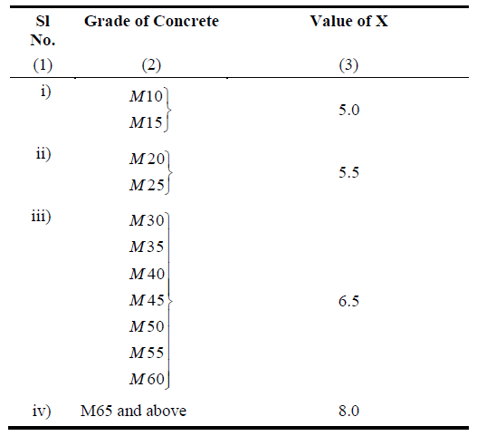

Table A-2: Assumed Standard Deviation (Table 2: IS 10262:2019)

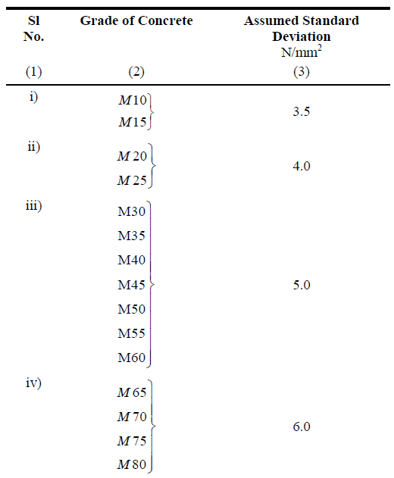

Table A-3: Environmental Exposure Conditions (Table 3: IS 456-2000)

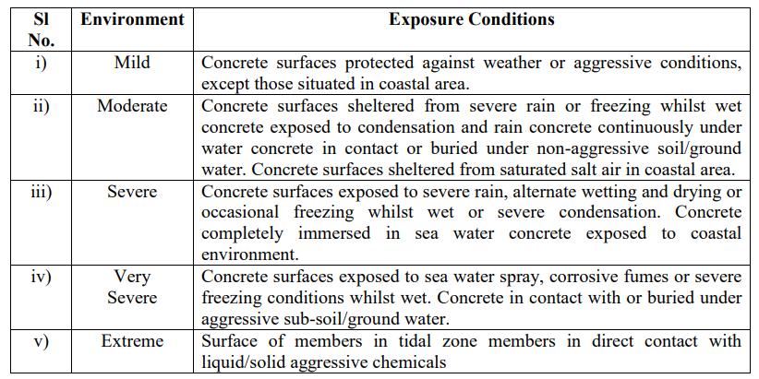

Table A-4: Minimum Cement Content, Maximum Water-Cement Ratio and Minimum Grade of Concrete for Different Exposures with Normal Weight Aggregate of 20 mm Nominal Maximum Size (Table 5: IS 456-2000)

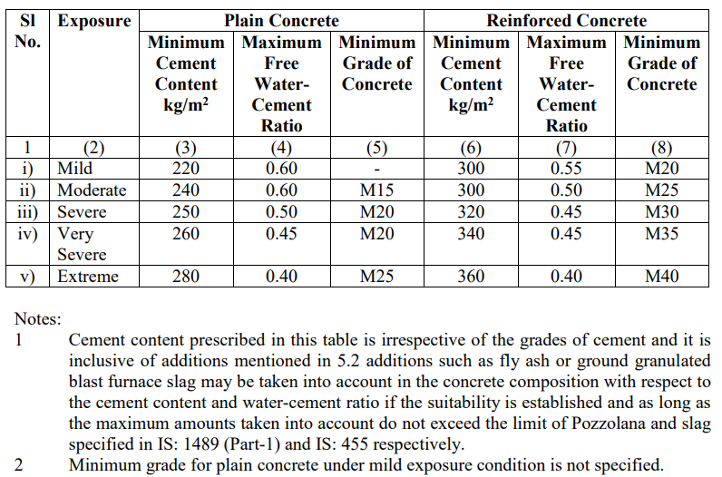

Table A-5: Water Content per Cubic Meter of Concrete for Nominal Maximum Size of Aggregate (Table 4: IS 10262:2019)

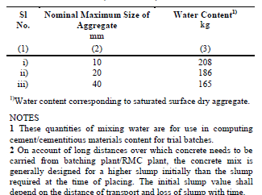

Table A-6: Volume of Coarse Aggregate per Unit Volume of Total Aggregate for Different Zones of Fine Aggregate for Water-Cement/Water-Cementitious Materials Ratio of 0.50 (Table 5: IS 10262:2019)

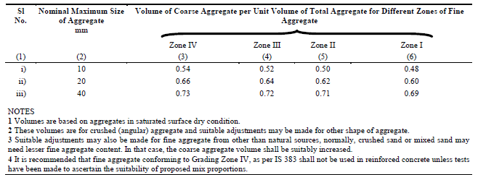

Table A-7: There are 4 types of grading zones for fine aggregates(sand) namely Grading zone, I-IV. All grading zones and their recommended value for different sieve sizes (IS 383, Table 4(Cl. 4.3))

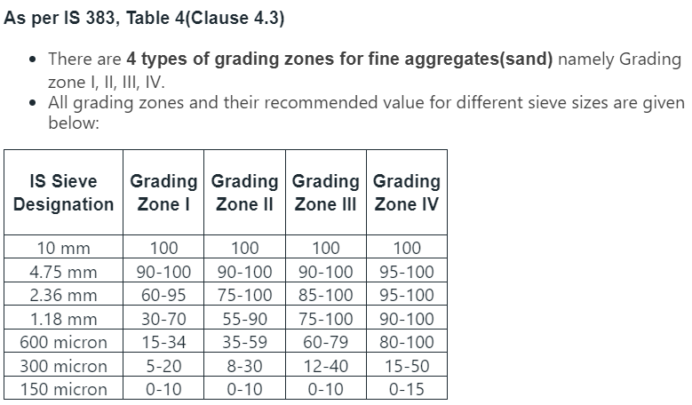

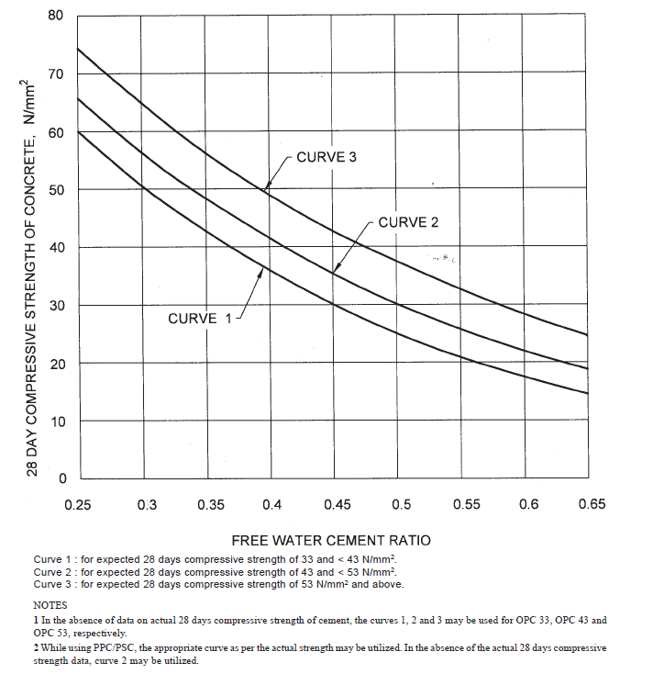

Figure A-1: Relationship between free water cement ratio and 28 days compressive strengths of concrete for cements for various expected 28-day compressive strengths.

(Fig. 1: IS 10262:2019)

**Appendix – B**

**Load Versus Time Plots**

(a)

(b)

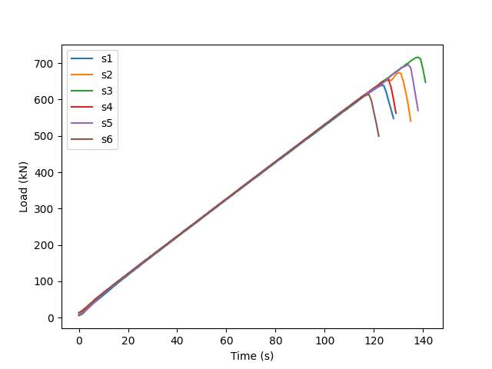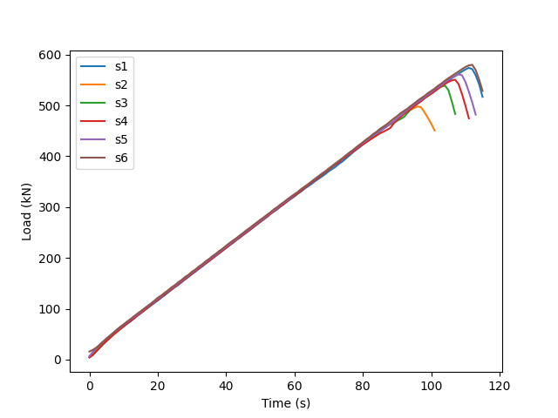

Figure B-1: Sample M25 (Load versus Time Plot) (a) 7-Day Compressive Strength Test

(b) 28-Day Compressive Strength Test

(a)

(b)

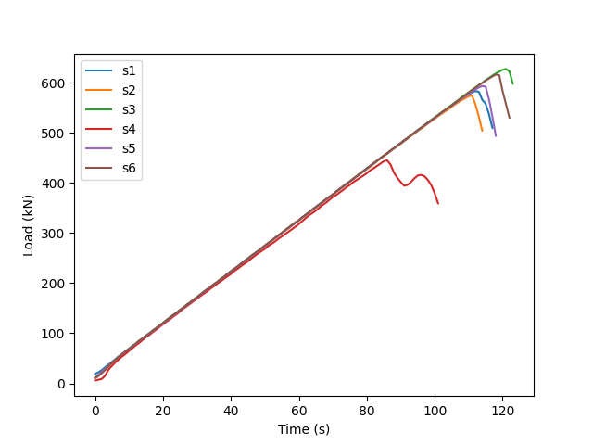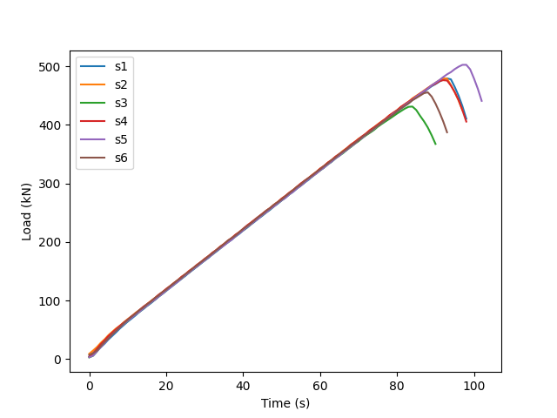

Figure B-2: Sample M25 + 20% Marble Dust

(Load versus Time Plot) (a) 7-Day Compressive Strength Test

(b) 28-Day Compressive Strength Test

(a)

(b)

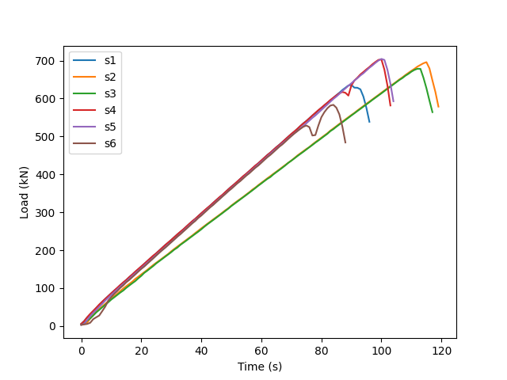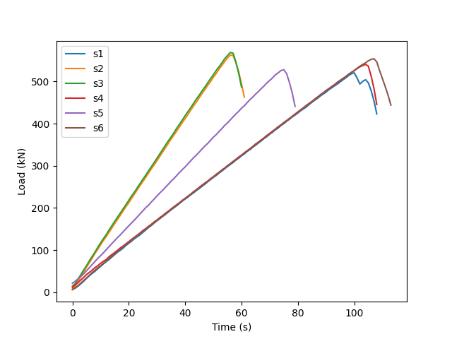

Figure B-2: Sample M25 + 20% Fly Ash

(Load versus Time Plot) (a) 7-Day Compressive Strength Test

(b) 28-Day Compressive Strength Test